**Module 3: IAM Users Assignment**

**Problem Statement:**

You work for XYZ Corporation. To maintain the security of the AWS account and

the resources you have been asked to implement a solution that can help easily

recognize and monitor the different users.

**Tasks To Be Performed:**

1. Create 4 IAM users named “Dev1”, “Dev2”, “Test1”, and “Test2”.

2. Create 2 groups named “Dev Team” and “Ops Team”.

3. Add Dev1 and Dev2 to the Dev Team.

4. Add Dev1, Test1 and Test2 to the Ops Team.

Go to AWS IAM Console

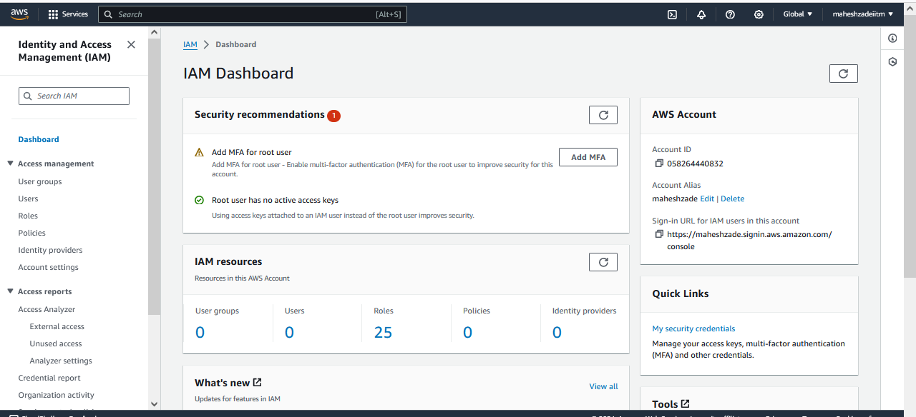

. Create 4 IAM users named “Dev1”, “Dev2”, “Test1”, and “Test2”.

Create the Dev1 user

Click on next only

Now Download.csv file for the password to login the IAM User

And keep the file in Safe folder

Now follow the same Above Steps and create the below users

Dev2”, “Test1”, and “Test2”.

All the Download.csv file downloaded and all the 4 users are created

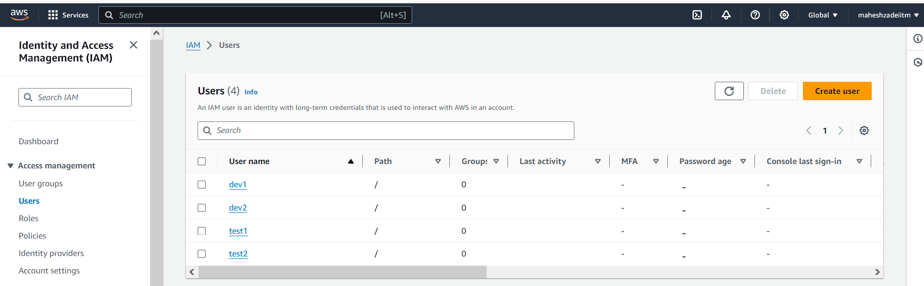

Now go to IAM Groups

Create 2 groups named “Dev Team” and “Ops Team

Click on create user Group

Two Groups are created.

Go to Dev Group

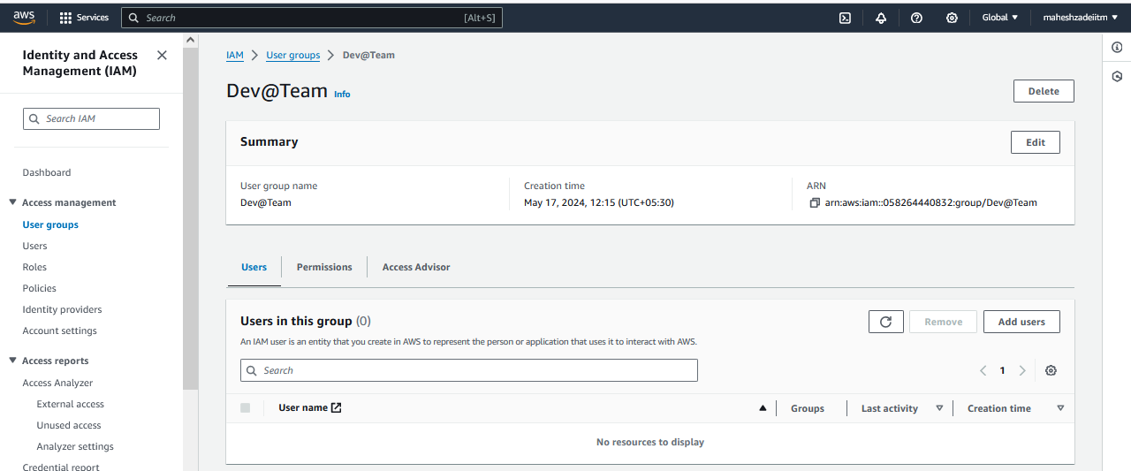

Add the below users

Add Dev1 and Dev2 to the Dev Team.

Click on Add users

Module 3: IAM Users Assignment Completed

Thanks

Pls check and confirm.